BENCH STAFF ROWAN’s LAW ACKNOWLEDGEMENT- Hockey Canada Registration for Bench staff

Copy and paste the below link in to a browser to register as a coach, bench staff or on ice volunteer.

https://registration.hockeycanada.ca/Registration/AccountLogin.aspx?ReturnUrl=%2fregistration%2f%3fID%3d5320&ID=5320t

- Click on register a participant. (If you are not listed please register yourself as a participant) . if you are not able to log in (means you haven’t registered anyone online in the past) you will need to create an online account.

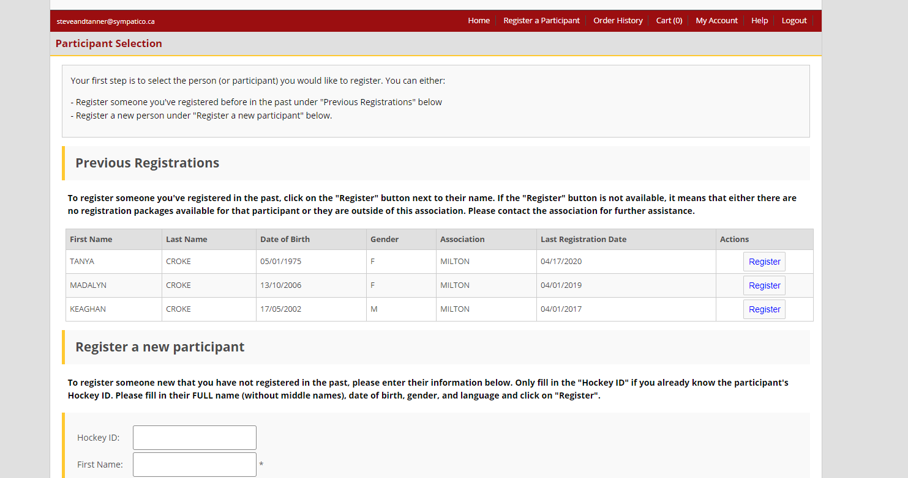

2.Select Bench Staff

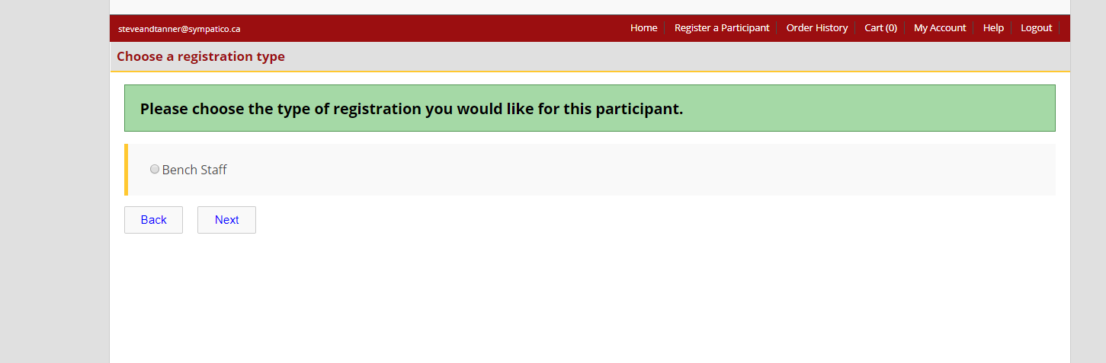

- Select the bench staff position you will hold

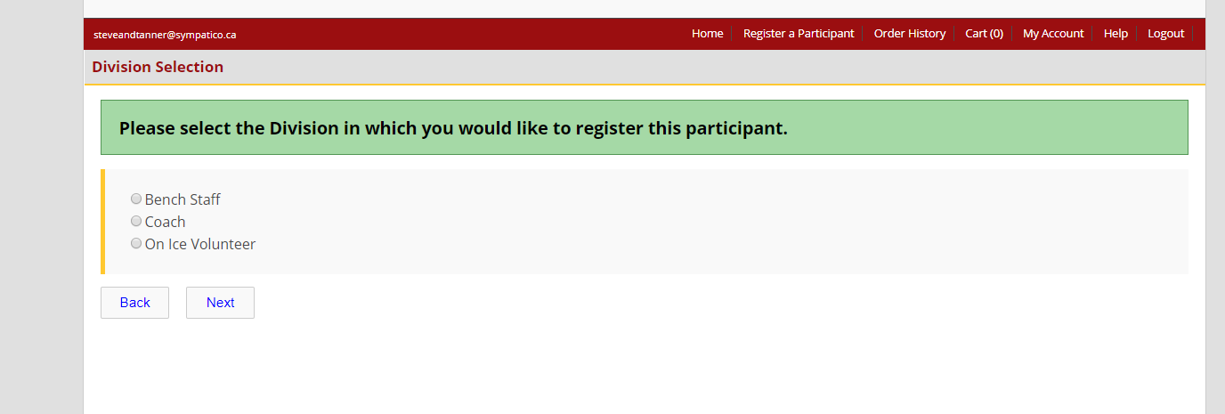

- Select the position you will hold
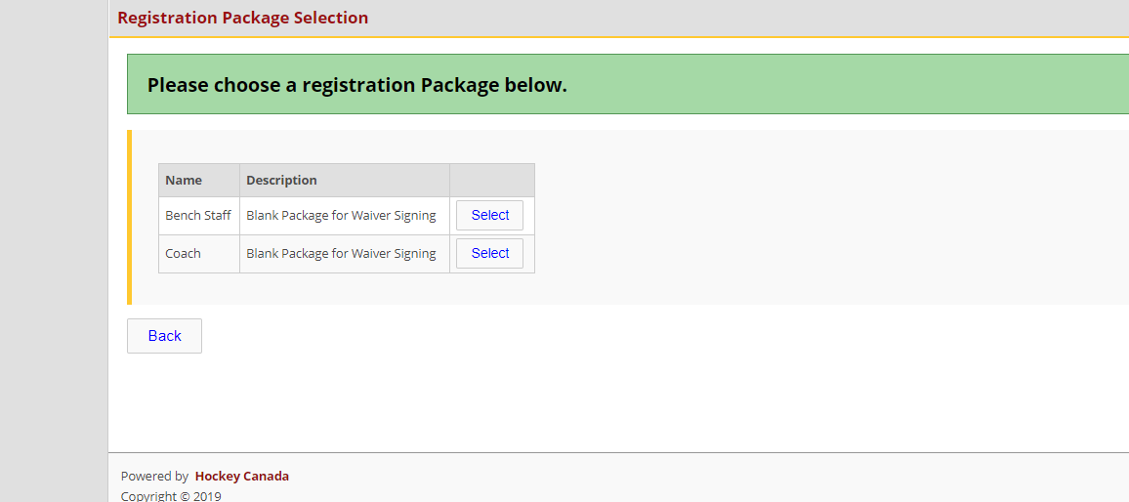
- Complete the address and contact information
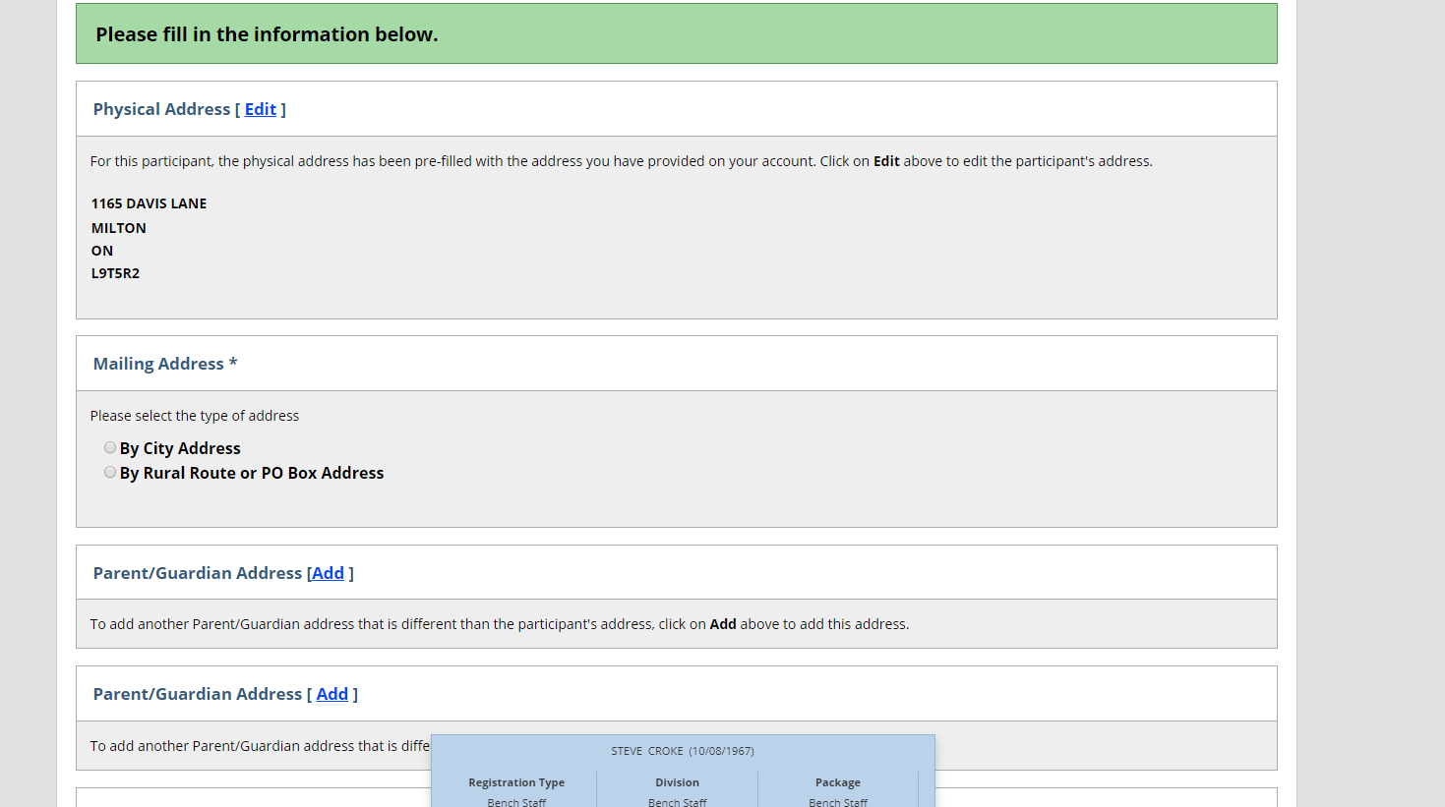

- Agree to all 3 waivers listed., Rowan’s law, Hockey Canada Agreement and Hockey Canada Waiver

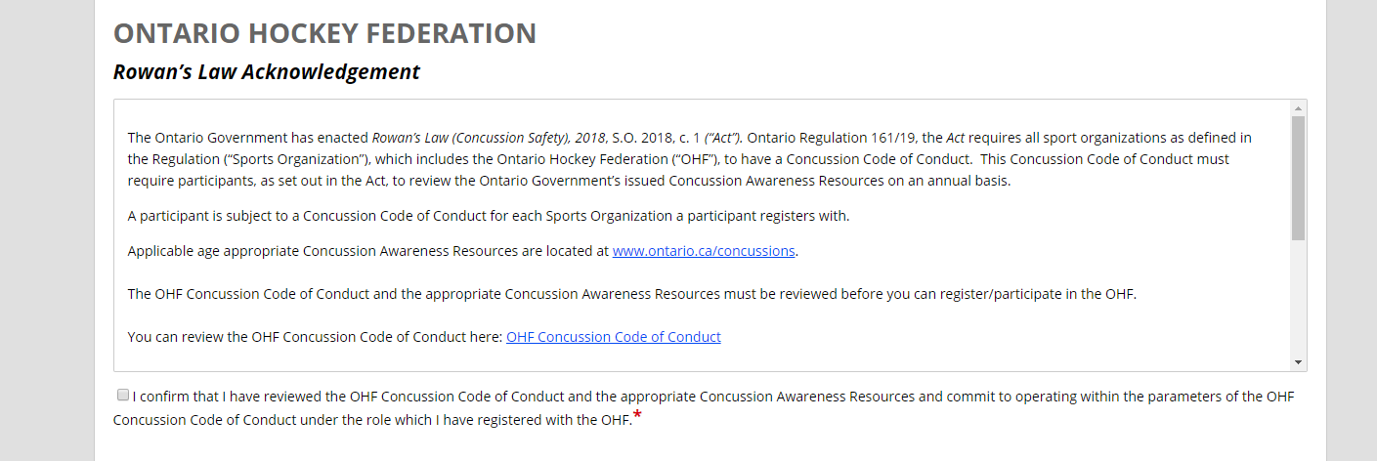

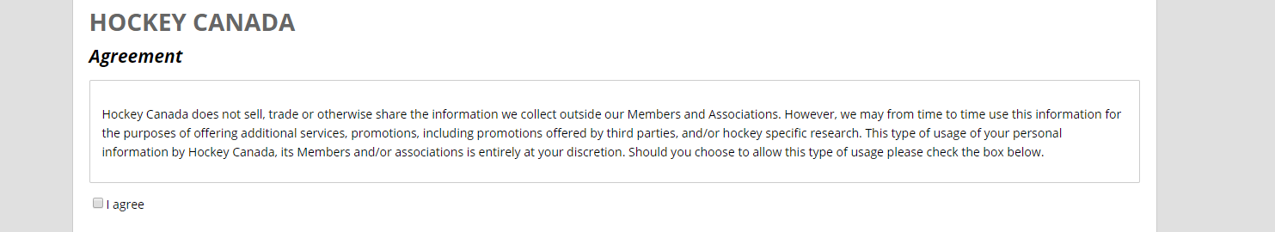

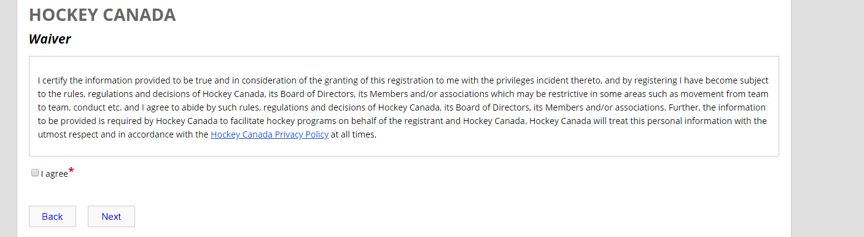
- Select Review

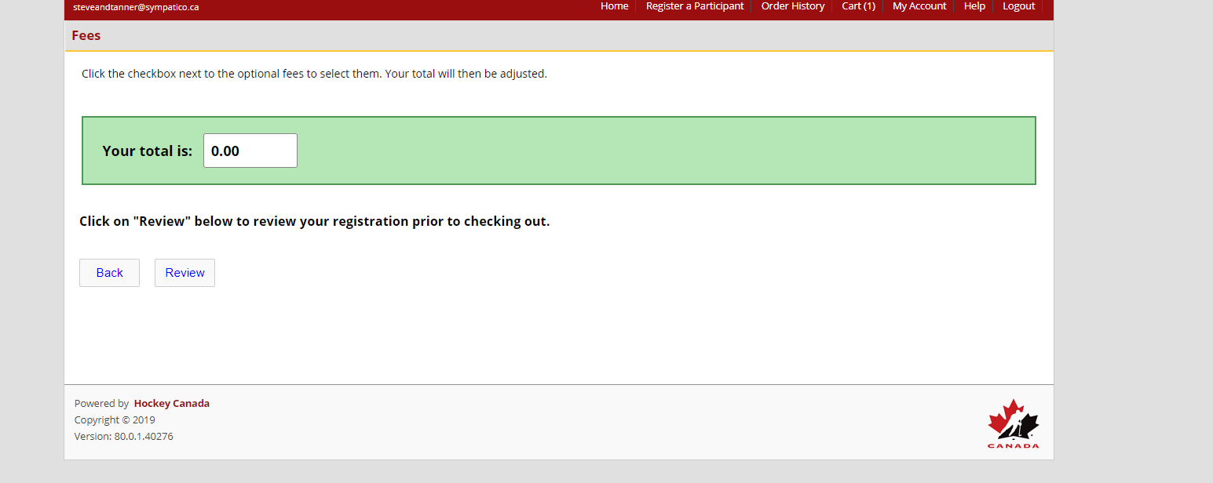

- Select Add to Cart
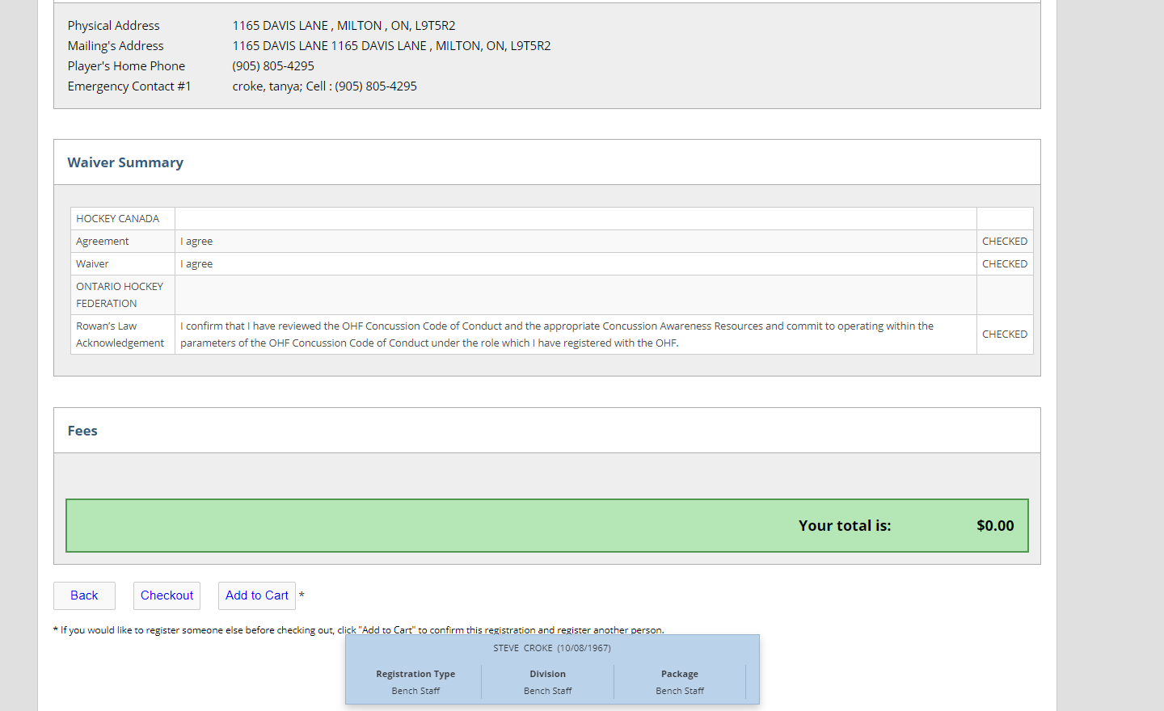
9.Select Check out

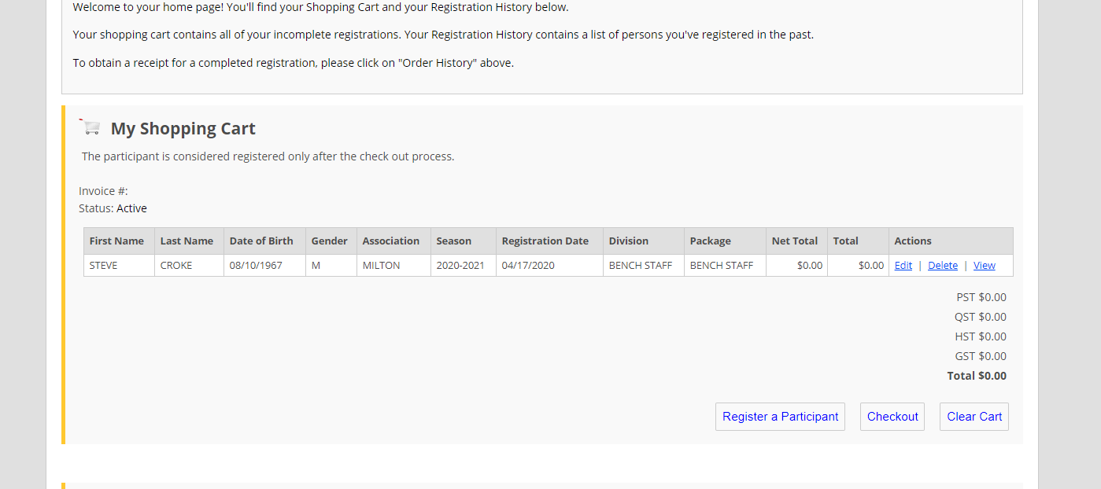

10. Select Credit Card and select next (it is $0 you wont have to enter details)

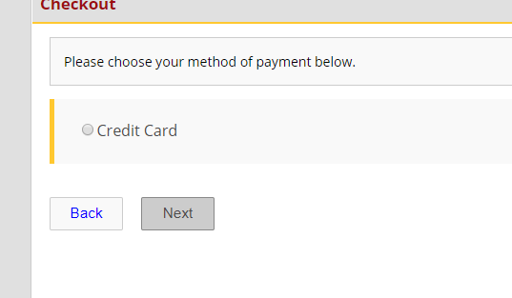

11. You are now finished.

Send repadmin@miltonwinterhawks.com a note to let us know you have compelted this step.

