Two Tone W/H Hat
Blue/white
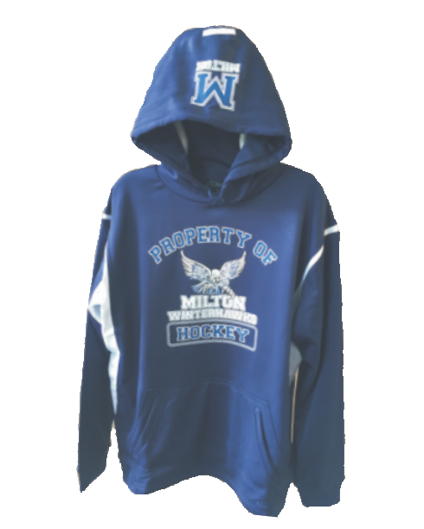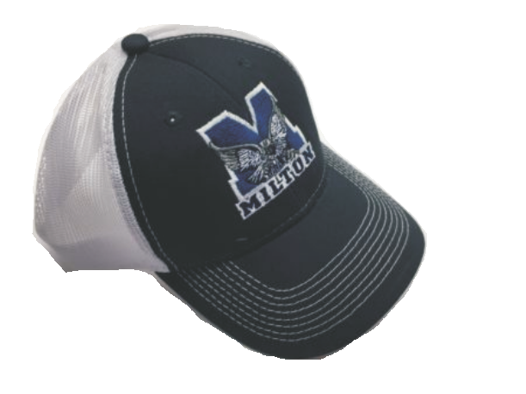one size fits all
$14.95
New Era Fitted Hat Sizes S/M, M/L, L/XL Embroidered Logo
$18.95

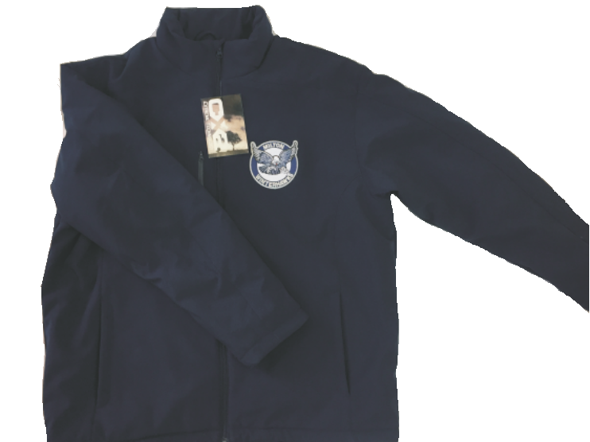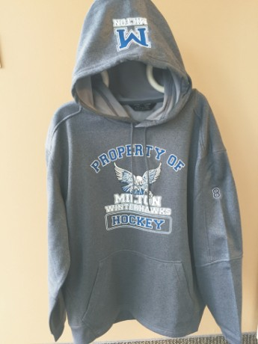

Nylon Bag

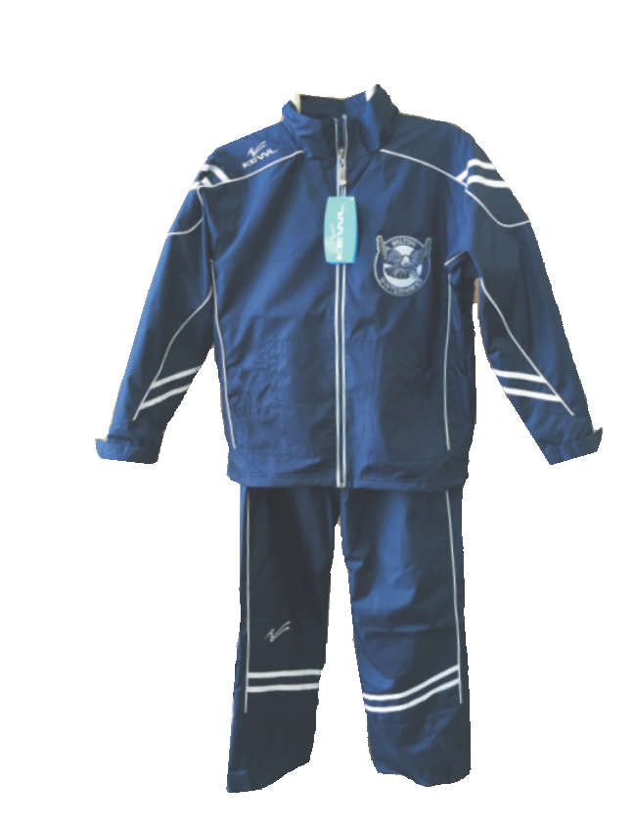Property of Winterhawks ATC Performance Hoodie Available in Blue or Grey Youth Small up to Adult XXXL Youth - $36.95 Adult $39.95

KEWL Tracksuit
Youth XS-XL, Adult S-XXL Embroidered Logo
Youth - $89.95 Adult - $94.95

Tech Jacket Winter Embroidered Logo Youth XS - XL $74.95
Adult S - XXL $79.95

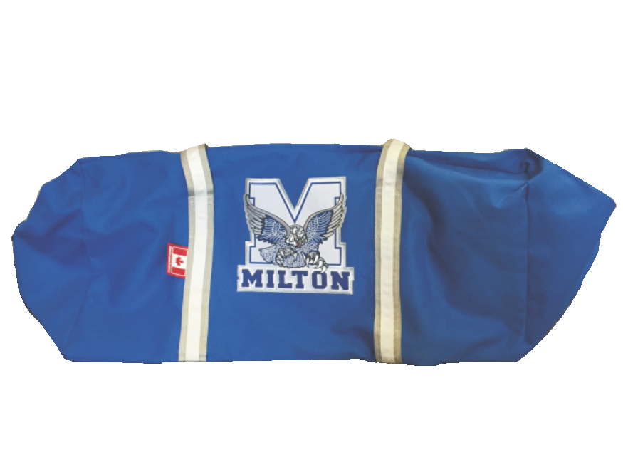Canvas Bag
Includes Sewn Crest and Number
36” Junior Bag - $79.95
36” Pro Bag - $84.95
40” Pro Large Bag - $89.95
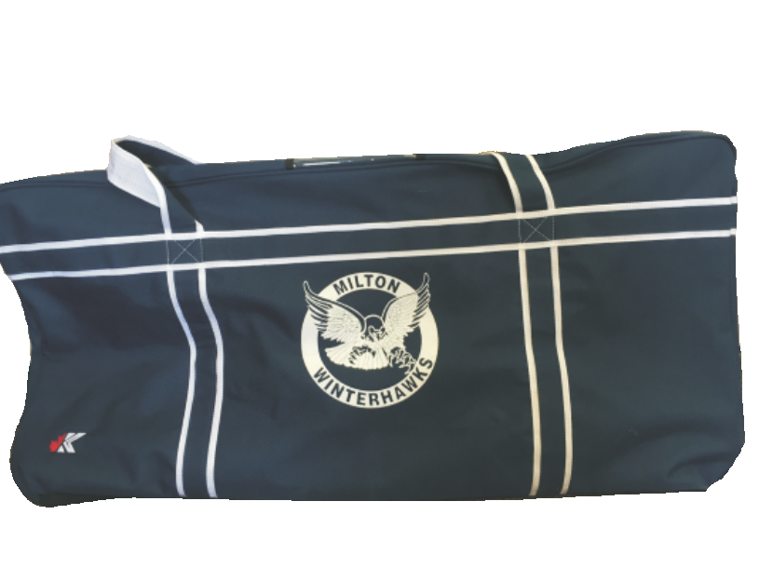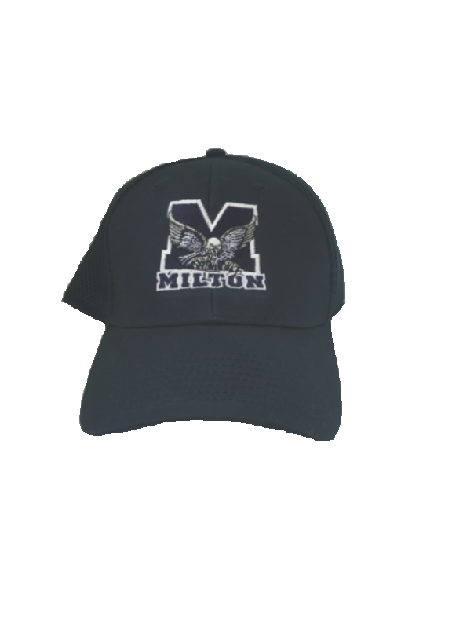Includes Screen Print Logo
30” Junior - $39.95
36” Intermediate - $44.95
40” Pro - $49.95

$6.50 for Player Number on any piece
All work on Apparel and Jerseys is done at KCK. All prices are not including taxes
Sample sizes are available upon request

